**Definition: Create the design using Figma Design Tool Color Gradients.**

**Solution:**

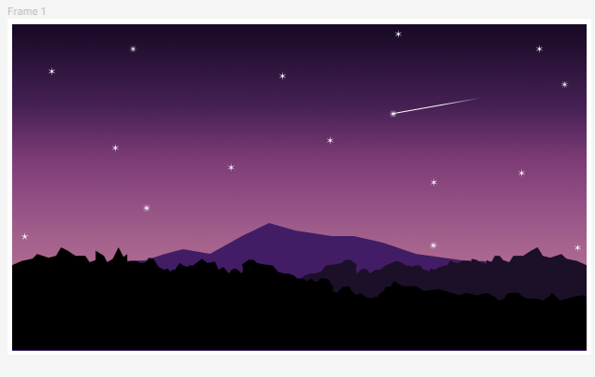

**Steps:**

* First Open Figma in browser mode.
* Then create the new document **File à New Figma Design.**
* Now add one frame using the Frame tool and select a frame of width=”**734px”** and height=”**538px”** on your canvas.
* Take the Rectangle tool and draw a rectangle of width=**”615px”** and height=**”350px”**. Fill the rectangle with vertical linear colour **“**#**190A27”** and “#**D38B97**”.
* Now draw another rectangle of width=**”615px”** and height=**”110px”.** Shape it as a mountain. Fill the rectangle with the colour **“**#**000000”**.
* Then draw 2 more rectangles of width=**”615px”** and height=**”110px”** to shape it as a different mountain. Fill one rectangle with the colour **“**#**1C0F28”** and another with the colour **“**#**421D66”.**
* To draw a star, take the star shape and give it a different count**.**
* Now, Go to the **Export** button in the property panel. And **Export** it with .**JPG/.PNG** format.